Supply of Reality Capture Services
Reference: Project #054339
BIDS Categories: 6196
Issue Date: September 2, 2022
Closing Date: September 18, 2022
----------------------------------------------------------------------------------------------

Overview:
- ExxonMobil Canada Properties, by its managing partner ExxonMobil Canada Ltd. (EMCP) and/or Hibernia Management and Development Company Ltd. (HMDC) are in the process of pre-qualifying companies who can supply digital reality capture for their onshore and/or offshore Newfoundland and Labrador requirements. Supplier shall provide all management, personnel, processes, materials, tools, equipment, applicable certifications and facilities as may be required to ensure all equipment covered by this pending Agreement shall be fabricated and supplied to meet all statutory requirements, codes of practice and applicable specifications.
- The intention is to have this scope of work cover the requirements of the Hibernia Project*, and the Hebron Project. For clarity, the scope of work includes not only the foregoing, but may include at EMCP and/or HMDC’s discretion, future work related to minor changes to the scope of work described herein, in which EMCP and/or HMDC may engage onshore or offshore Newfoundland and Labrador, for oil and gas facilities as well as exploration or subsea related activities
- While not planned, it should be noted that the resulting RFP and Agreement may require inclusion of and/or extension to other operators in the area, project co-venturers, suppliers and/or affiliated companies.
- For work related to the Hibernia Project*, HMDC supports providing opportunities to Canadian, and, in particular, Newfoundland and Labrador companies and individuals, on a commercially competitive basis. Suppliers expressing interest in providing services or materials, if they are selected to bid, will be required to complete a Canada-Newfoundland and Labrador Benefits Questionnaire at the bid stage. For work related to the Hebron Project, EMCP supports providing opportunities to Canadian, and, in particular, Newfoundland and Labrador companies and individuals, on a commercially competitive basis. Suppliers expressing interest in providing services or materials, if they are selected to bid, will be required to complete a Canada-Newfoundland and Labrador Benefits Questionnaire at the bid stage Hibernia Management and Development Company Ltd. (HMDC) and/or ExxonMobil Canada Properties, by its managing partner ExxonMobil Canada Ltd. (EMCP),encourage the participation of members of designated groups (women; Indigenous Peoples; persons with disabilities; and members of visible minorities) and corporations or cooperatives owned by them, in the supply of goods and services.

Supplier Diversity

Diverse Ownership (Completion of this section is voluntary)
A Diverse supplier is a business that is at least 51 % owned and controlled by a member(s) of one or more of the designated groups identified below. Please indicate which of the following designated group(s) are applicable to your business:
☐ Women
☐ Indigenous Peoples
☐ Visible Minorities
☐ Persons with disabilities
☐ LGBT+

Certification for Diverse Businesses

There are currently national certifying organizations that cover certification for businesses owned by:
- Indigenous Peoples
- Visible Minorities
- Women
- LGBT+

The Projects will continue to look for organizations that can provide certification support to businesses owned by persons with disabilities.

If you indicated that your business is owned by a member of a designated group, are you currently certified as a diverse-owned business?
☐Yes ☐ No

Through which certifying organization is your business certified? ______________________________

If you are a NL registered business and are not currently certified, would you be interested in learning more about certification?
☐Yes ☐ No

Scope of Work Overview:

The scope of work/supply includes, but is not limited to:

- Provision of digital reality capture services, including but not limited to Laser Scan (3D point cloud), and Photogrammetry data capture.

Additionally, the selected supplier will be required to meet all technical and Safety, Security, Health, and Environmental (SSHE) specifications and safe work practices of EMCP and HMDC, their affiliates as appropriate.

Minimum Technical Requirements
The data capture should conform to the below technical requirements, or be stated otherwise:
Laser Scan Capture Guardrails
Data Content
- Point cloud providers shall deliver registered point cloud data
Scan data registration to the site/target monuments, for enabling integration with existing data models and geo referencing capabilities.
- Each point cloud scan shall include coordinates and if applicable, initial heading, for the camera
The coordinates shall be in 3 dimensions and must include the units.
- Each point shall include depth, color (RGB) and intensity.
- Point cloud providers shall deliver the metadata for each point cloud file
The metadata information shall include at a minimum Laser Scan Capture Position data outlined below;

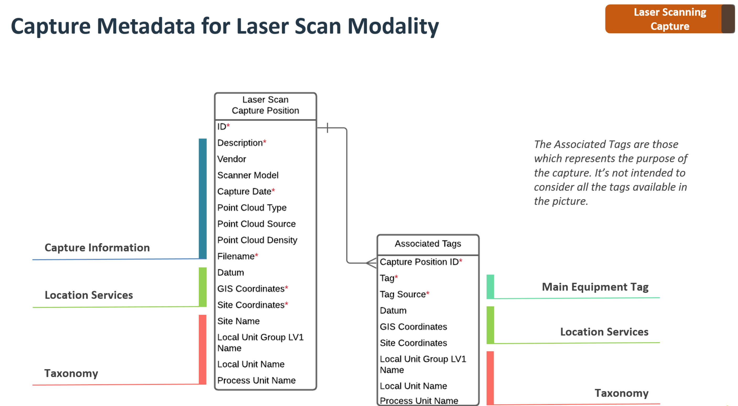

Data Format
- Point cloud data must be uploaded using standardized formats as E57 or LAS
E57 is a format that is widely accepted in most of the tools available in the market and LAS is specialized for drone data collection. In addition, both are vendor-neutral formats for storing point clouds. There formats are standardized respectively by ASTM E2807 and ASPRS LAS Specification 1.4.

Data Delivery
- Files must be stored in a network folder, or hard-drive
Application will match metadata and Files using the filename registered in the metadata process. Both panoramic file and metadata register file must be in the same folder.

Process Guardrails
- Recommended fidelity should follow Tier 2 as shown below
Example: For Fabrication (Pipe spools / Equipment), accuracy for measurements should be 1/8 in.
- Geolocation data should be provided by survey grade GPS equipment
The coordinates shall be provided on high precision with at least 8 decimal digits, so the location can be stored with maximum precision for later enabling auto tagging. The coordinates must be in accordance with ISO 6709. The accuracy standard must be in accordance with FGDC-STD-007.
- The vendor must fill out the metadata for each capture position

Photogrammetry Data Capture Guardrails
Data Content
- Photogrammetry providers shall deliver 2:1 panoramic high-resolution images per capture position
Recommended imagery specs should follow use cases as shown below.

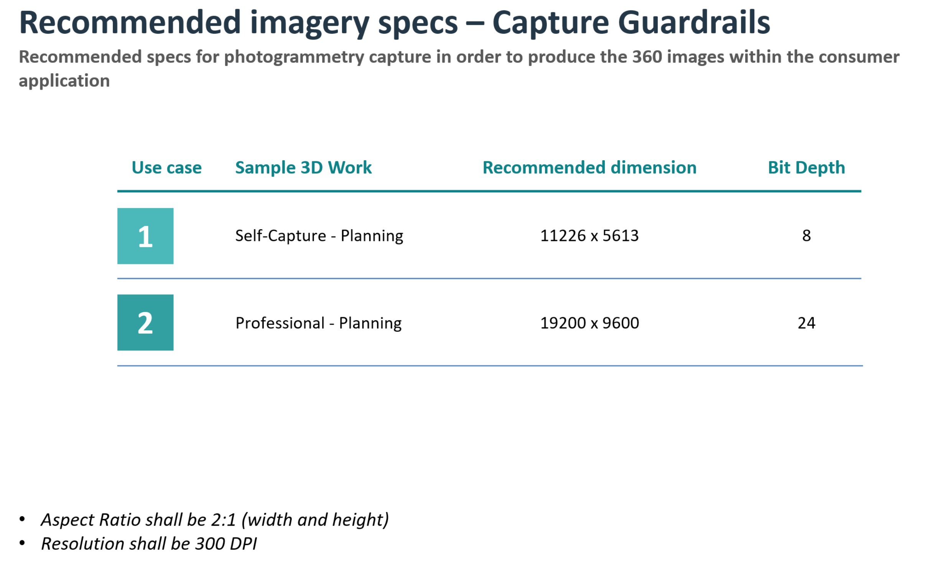

- Photogrammetry providers shall deliver the metadata for each image file
The metadata information shall include at a minimum Photogrammetry Capture Position data outlined below;

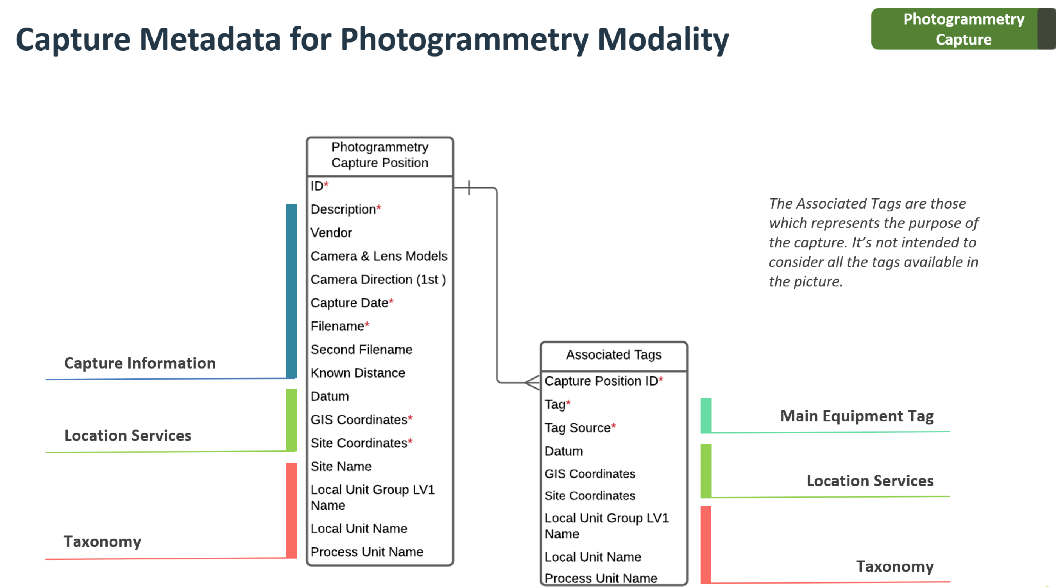

Data Format
- The panoramic images shall be provided in JPEG or PNG
Both are low compression formats used in digital photography, widely used for high-quality pictures and it is supported by all browsers and image editing software. These formats are standardized by ISO/IEC 10918, ISO/IEC 15444 and ISO/IEC 15948.

System Architecture
- Files must be stored in a network folder, or hard-drive
Application will match metadata and Files using the filename registered in the metadata on-ramp process. Both panoramic file and metadata register file must be in the same folder.

Process Guardrails
- Recommended fidelity should follow Tier 3 and 4 as shown below
Example: For planning (walk-downs), accuracy for measurements should be 3 in. For GIS (Pipelines) accuracy for measurements should be feet.
- Geolocation data for Capture Location should be provided with survey grade GPS equipment
The coordinates shall be provided on high precision with at least 7 decimal digits, so the location can be stored with maximum precision for later enabling auto tagging. The coordinates must be in accordance with ISO 6709. The accuracy standard must be in accordance with FGDC-STD-007.
- The panoramic picture shall consider stitching techniques such as exposure bracketing
These stitching techniques ensure the quality of the picture by removing artifacts such as sunlight reflections or flashes. The article “Removing Photography Artifacts using Gradient Projection and Flash-Exposure Sampling” Amit Agrawal, Ramesh Raskar, Shree Nayar, Yuanzhen Li, 2005, describes the process.
- The vendor must fill out the metadata for each capture position

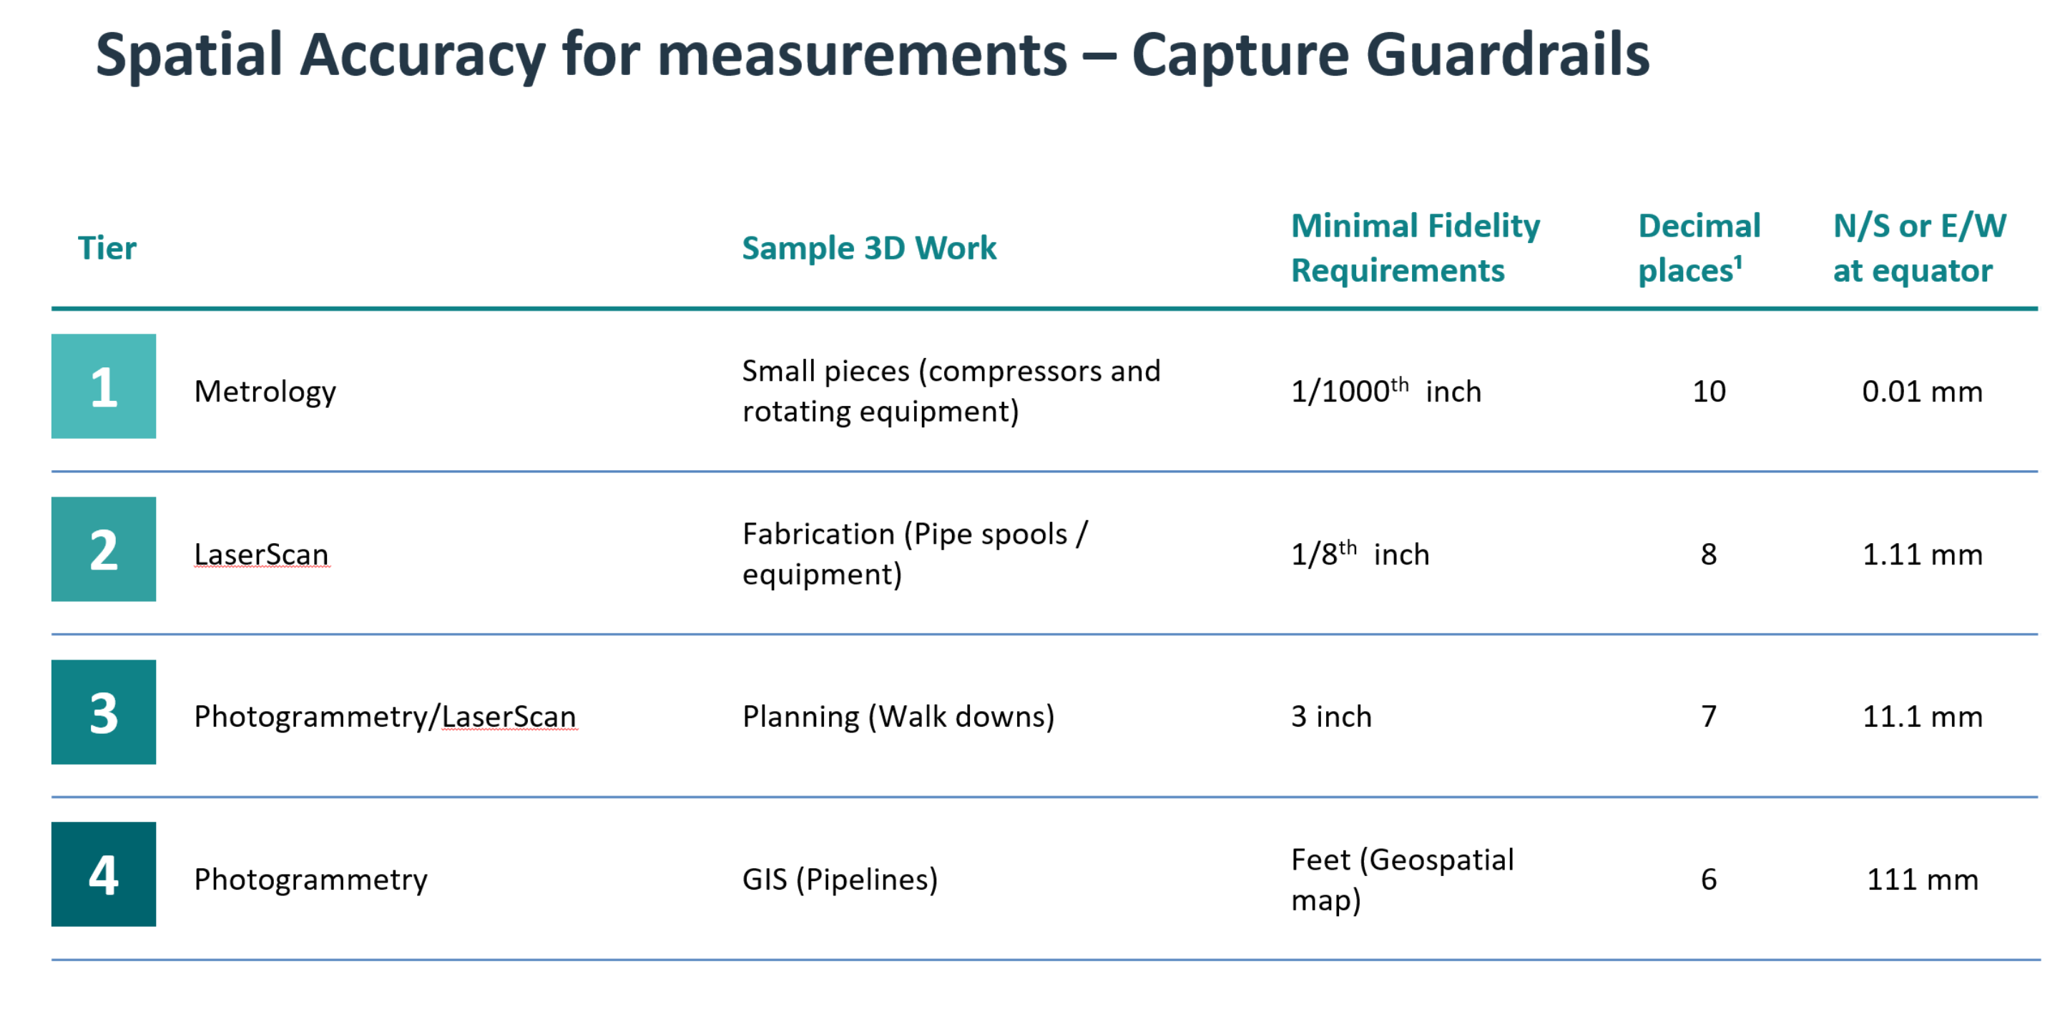

Submission Requirements
Supplier submissions in response to this Expression of Interest(including pre-qualification) must include the afore-mentioned reference number, as well as the following information:
1. Completed EMCP / HMDC SSHE pre-qualification questionnaire. (Available through BIDS – see contact information below2. Completed EMCP / HMDC QA/QC pre-qualification questionnaire. (Available through BIDS-see contact information below.)
2. Information demonstrating qualification for the Scope of Work detailed above.
3. Information demonstrating vendor can meet minimum technical requirements detailed above
4. Describe your experience operating under and familiarity with, the benefits provisions of the Canada-Newfoundland and Labrador Atlantic Accord Implementation Act, and your experience with any similar regimes in other parts of Canada or internationally. At the NRFP/ITT stage, bidders will be required to indicate how they comply with the above.

5. Please acknowledge that responsible management personnel have read, understand and will support requirements to comply with the following where applicable
i. Section 45 of the Canada-Newfoundland and Labrador Atlantic Accord Implementation Act
iii. The Hebron Benefits Agreement and Hebron Benefits Plan
iv. The Hibernia Benefits Plan, the HSE Benefits Agreement and HSE Benefits Plan

6. Submitted information is to be provided in separate PDF (or native file) submissions and not submitted as one combined file. Please be aware that Company is limited to a 10MB file size for receiving e-mail. Should the file size exceed 10MB, please contact the Contracts Manager identified below to have FileShare setup for your use.
7. EOI / NRFP contact details for respondent, including the following:
  - Full legal company name
  - Mailing address and physical address (if different)
  - Contact name, position, email and phone number
The data submitted in response to the aforementioned questionnaires will be used to evaluate your company’s ability (and those of your preferred sub-contractors / suppliers where applicable) to perform these services or provide these materials. It will focus primarily on:
- Past safety performance
- Applicable experiences
- Project execution skills
- Project management skills & integration skills
- Available technologies with proven performance
- Current capability
- Personnel qualifications
- Financial capacity

We will evaluate this data and develop a final list of suppliers who will be asked to submit formal competitive bids. We reserve the right to make the final determination of which suppliers will receive the Non-Binding Request for Proposals (NRFP) or Invitation to Tender (ITT) and which suppliers will be awarded the final agreement.
This Expression of Interest (including pre-qualification) is not a pre-qualification of suppliers for other EMCP / HMDC work, but is limited to the scope aforementioned. In addition, participation in this Expression of Interest (including pre-qualification), including any statements whether oral or written between EMCP / HMDC and your company, shall not create or be deemed to create any binding legal relationship or contract, or be construed to do so between EMCP / HMDC and your company. All costs associated with the preparation of your response to this expression of interest shall be at your expense.
This Expression of Interest (including pre-qualification) may or may not result in the issuance of an RFP/ITT and may or may not result in the award of an agreement. If you respond to this Expression of Interest (including pre-qualification) and your company is selected to be on the bidders’ list, your company name, your designated company representative’s name and business contact information may be posted on public websites. Similarly, if you are selected for award, the same information may also be posted, indicating that the work has been awarded to your company.
* It should be assumed that the Hibernia Project includes, but is not limited to, current and planned Hibernia and Hibernia Southern Extension operations as well as future development on behalf of Hibernia (operated by Hibernia Management and Development Company Ltd.) and/or Hibernia Southern Extension participants (operated by ExxonMobil Canada Properties).
Responses must be submitted electronically by the closing date to all of the EMCP and/or HMDC e-mail addresses noted below:

Hibernia Project
Hibernia Management & Development Company Ltd. (HMDC)
Attention: Jennifer O’Keefe
jennifer.k.okeefe@exxonmobil.com
Phone: (709)273-1587

Hebron Project
ExxonMobil Canada Properties
Attention: Jennifer O’Keefe
jennifer.k.okeefe@exxonmobil.com
Phone: (709) 273-1587

Finally, potential suppliers, if they have not already done so, should register with BIDS using the following contact information:

Phone: 1-800-270-4611
E-mail:jayde.mcconchie@bids.ca
https://bidsalert.com/canada/home

